1. **Write a php program to find the largest of three numbers using if else ladder.**

<?php

$a=15;

$b=10;

$c=12;

if($a>=$b && $a>=$c)

{

echo "a=$a is larger<br>";

}

else if($b>=$c)

{

echo "b=$b is larger<br>";

}

else

{

echo "c=$c is larger";

}

?>

OUTPUT:

a=15 is larger

1. **Write a PHP program to check whether the given number is prime or not using for loop.**

<html>

<body>

<form method="post">

Enter a number:

<input type="text" name="num">

<input type="submit" value="submit">

</form>

</body>

</html>

<?php

if($_POST)

{

$num=$_POST['num'];

function prime($num)

{

for($x=2;$x<$num;$x++)

{

if($num%$x==0)

{

return 0;

}

}

return 1;

}

$a=prime($num);

if($a==0)

echo "$num is not a prime number";

else

echo "$num is prime number";

}

?>

OUTPUT:

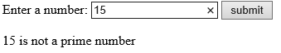

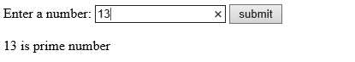

3**.Write a PHP program to reverse a given number using while loop.**

<html>

<font face=Consolas size=30 color=red>

<?php

$num=156;

$revnum=0;

echo "The given number is $num<br>";

while($num>1)

{

$rem=$num%10;

$revnum=($revnum*10)+$rem;

$num=($num/10);

}

echo "Reverse number is $revnum";

?>

</font>

</html>

OUTPUT:  
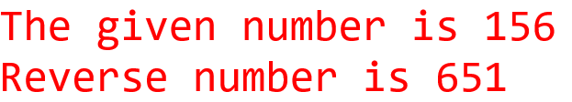

4**.Write the PHP program to print the fibonacci series using function.**

<?php

echo ("<h2> fibbonacci series</h2>");

function fib($n)

{

$f1=0;

$f2=1;

print "fibonacci series<br>";

echo "$f1<br>$f2<br>";

for($i=2;$i<$n;$i++)

{

$f3=$f1+$f2;

echo "$f3<br>";

$f1=$f2;

$f2=$f3;

}

}

print fib(5);

?>

OUTPUT:

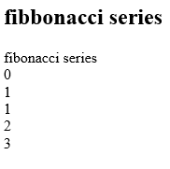

5**. Write a PHP program to illustrate different string functions.**

<?php

$str1="PHP is a SCRIPTING language";

$str2=" Sheshadripuram Degree College ";

echo " The string1 is $str1";

echo "<br>The length of the string1 is ".strlen($str1);

echo "<br>The length of the string2 is ".strlen($str2);

echo "<br>After trimming, string2 is: ".strlen(trim($str2));

echo "<br>Number of words in the string1 is ".str_word_count($str1);

echo "<br>The reverse of the string1 is ".strrev($str1);

echo"<br> String1 is in Lower case ".strtolower($str1);

echo"<br> String1 is in Upper rcase ".strtoupper($str1);

echo "<br>After replace php in to java is ".str_replace("PHP","Java",$str1);

echo "<br> Sub string of string1 is ".substr($str1, 18,34);

echo "<br> The language is present at ".strpos($str1,'language') ." position";

?>

OUTPUT:

The string1 is PHP is a SCRIPTING language  
The length of the string1 is 27  
The length of the string2 is 31  
After trimming, string2 is: 29  
Number of words in the string1 is 5  
The reverse of the string1 is egaugnal GNITPIRCS a si PHP  
String1 is in Lower case php is a scripting language  
String1 is in Upper rcase PHP IS A SCRIPTING LANGUAGE  
After replace php in to java is Java is a SCRIPTING language  
Sub string of string1 is language  
The language is present at 19 position

**6. Write a PHP program to implement calculator using switch case.**

<html>

<body>

<form method="POST">

<h2>First Number:</h2><input name="num1" type="text">

<h2>Second Number:</h2><input name="num2" type="text">

<h2>Enter operator</h2>

<select name="operator">

<option>+</option>

<option>-</option>

<option>*</option>

<option>/</option>

</select>

<input type="submit" name="sbt" value="Submit">

</form>

</body>

</html>

<?php

if(isset($_POST["sbt"]))

{

$n1=$_POST["num1"];

$n2=$_POST["num2"];

$cal=$_POST["operator"];

switch("$cal")

{

case "+";

$result=$n1+$n2;

echo "Addition of $n1 and $n2=$result";

break;

case "-";

$result=$n1-$n2;

echo "Subtraction of $n1 and $n2=$result";

break;

case "*";

$result=$n1*$n2;

echo "Multiplication of $n1 and $n2=$result";

break;

case "/";

$result=$n1/$n2;

echo "Division of $n1 and $n2=$result";

break;

}

**}**

**?>**

**OUTPUT:**

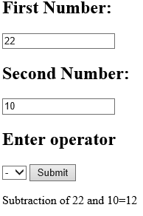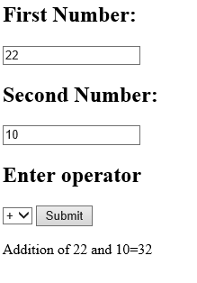

**7.Write a PHP program to find factorial of a number using for each loop.**

<?php

$n=4;

$fact=1;

$a=range(1,$n);

foreach($a as $val)

{

$fact=$fact*$val;

}

echo "the factorial of $n is $fact";

?>

OUTPUT:

the factorial of 4 is 24

**8.Write a PHP program to sort the given array.**

<?php

$cars=array("volovo","bmw","toyoto","xyz");

sort($cars);

for($i=0;$i<count($cars);$i++)

echo "$cars[$i]<br>";

?>

OR Using Bubble sort

<?php

$a=array(3,7,4,6,5);

echo "the given array is<br>";

foreach($a as $val)

echo "$val<br>";

for($i=0;$i<count($a);$i++)

{

for($j=0;$j<=count($a)-1;$j++)

{

if($a[$i]<$a[$j])

{

$temp=$a[$i];

$a[$i]=$a[$j];

$a[$j]=$temp;

}

}

}

echo "The sorted array is<br>";

for($i=0;$i<count($a);$i++)

echo "$a[$i]<br>";

?>

**OUTPUT:**

the given array is  
3  
7  
4  
6  
5  
The sorted array is  
3  
4  
5  
6  
7